Assignment 2
Objective: Analyze sales data using SQL with filtering, aggregation, and business queries.
Steps:
1.Load dataset into a SQL database.
CREATE DATABASE assignment2;
USE assignment2;
SHOW TABLES;
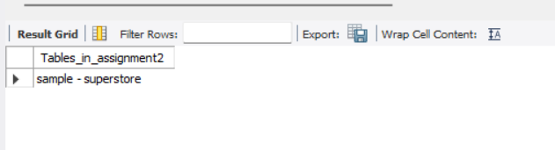
2.Explore table (schema, sample data).
describe `sample - superstore`;
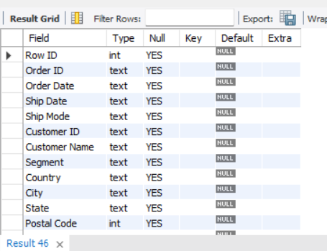
SELECT * FROM `sample - superstore`;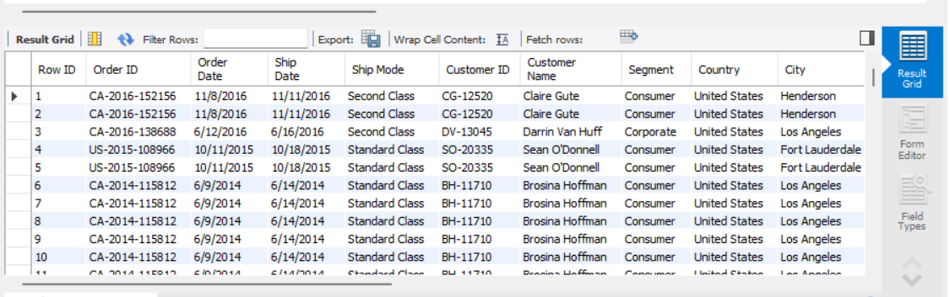SELECT * FROM `sample - superstore` LIMIT 10;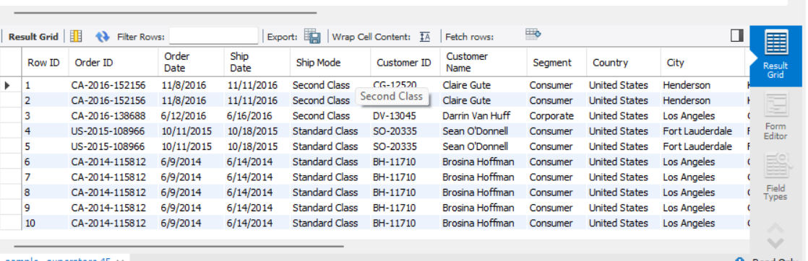
SELECT COUNT(*) AS Total_NumberOfRecords FROM `sample - superstore`;
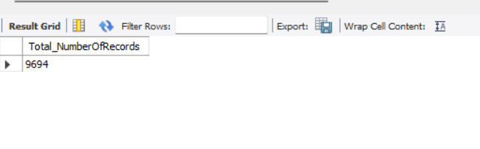
3.Apply WHERE filters (region, category, date, sales).
SELECT * FROM `sample - superstore` WHERE Region="West";
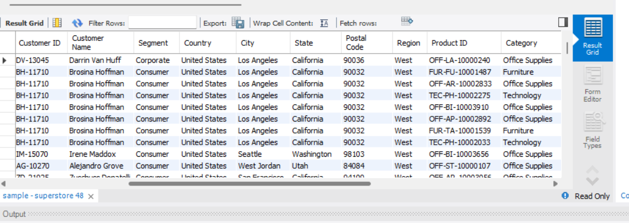

SELECT * FROM `sample - superstore` WHERE Region="South";
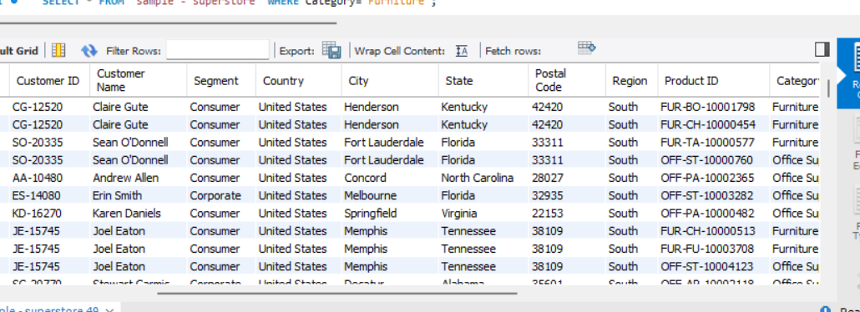
SELECT * FROM `sample - superstore` WHERE Region="Central";
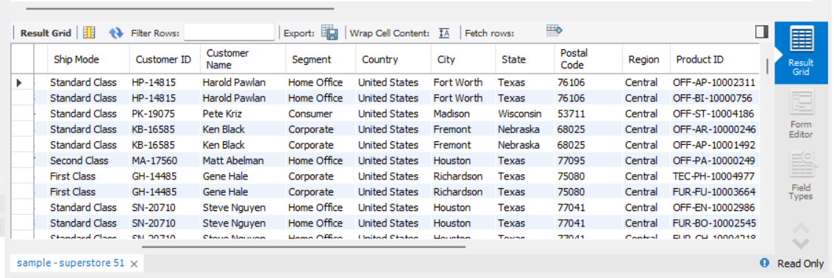
SELECT * FROM `sample - superstore` WHERE Category="Furniture";
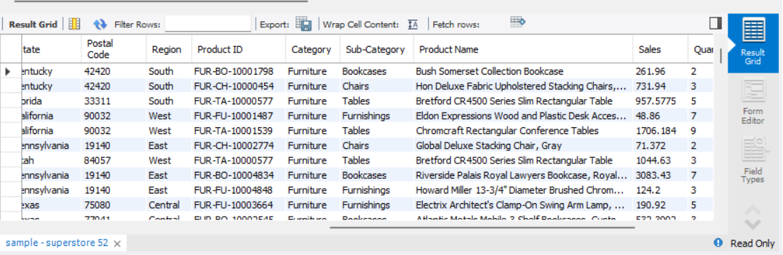SELECT * FROM `sample - superstore` WHERE Sales<200;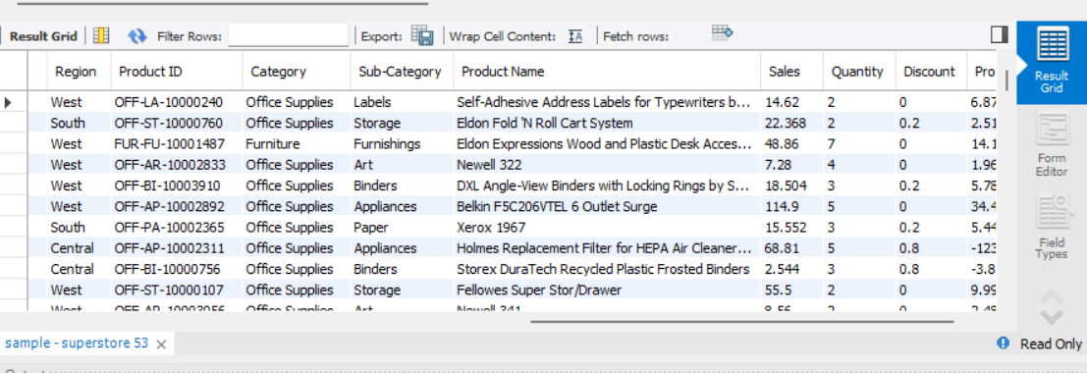

SELECT * FROM `sample - superstore` WHERE Sales>1000;
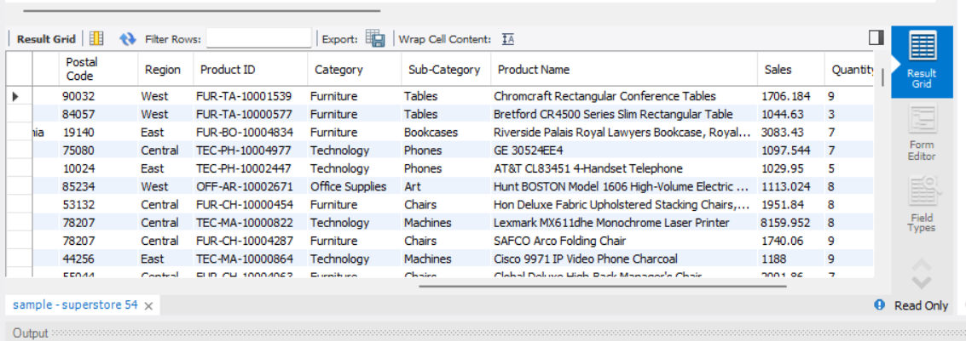
SELECT * FROM `sample - superstore` WHERE `Order Date`='12/10/2016' and `Ship Date`='12/10/2016'; 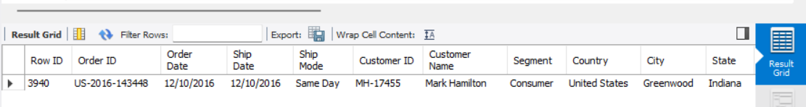
SELECT * FROM `sample - superstore` WHERE `Order Date`='12/10/2016';
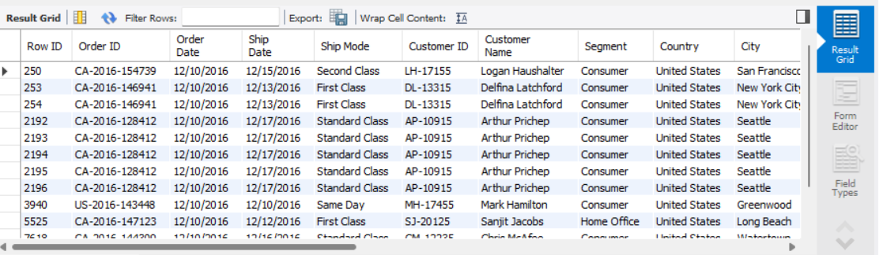
4.Use GROUP BY for aggregations (sales, quantity, averages).
SELECT Category ,SUM(Sales) AS TotalSales FROM `sample - superstore` GROUP BY Category;
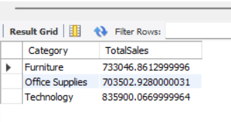
SELECT Region ,SUM(Sales) AS TotalSales FROM `sample - superstore` GROUP BY Region;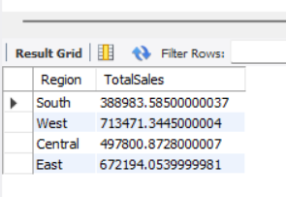
SELECT Category ,SUM(Quantity) AS TotalQuantity FROM `sample - superstore` GROUP BY Category; 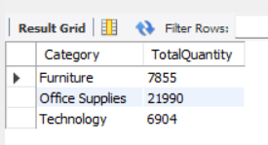
SELECT Region ,SUM(Quantity) AS TotalQuantity FROM `sample - superstore` GROUP BY Region; 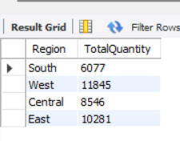
SELECT Category ,AVG(Sales) AS AverageSales FROM `sample - superstore` GROUP BY Category; 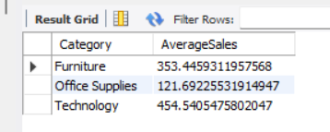
SELECT Category,SUM(Sales) AS TotalSales FROM `sample - superstore` GROUP BY Category ORDER BY TotalSales DESC LIMIT 10;
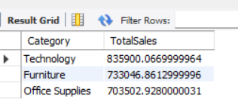

SELECT `Customer Name`,SUM(Sales) AS TotalSales FROM `sample - superstore` GROUP BY `Customer Name`ORDER BY TotalSales DESC LIMIT 10;
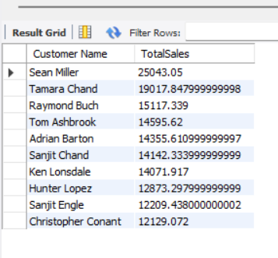
SELECT `Product Name`,SUM(Sales) AS TotalSales FROM `sample - superstore` GROUP BY `Product Name` ORDER BY TotalSales DESC LIMIT 10; 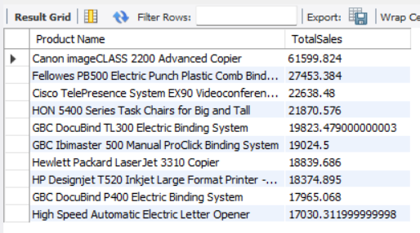
SELECT `Product Name`,SUM(Sales) AS TotalSales FROM `sample - superstore` GROUP BY `Product Name` ORDER BY TotalSales DESC LIMIT 10; 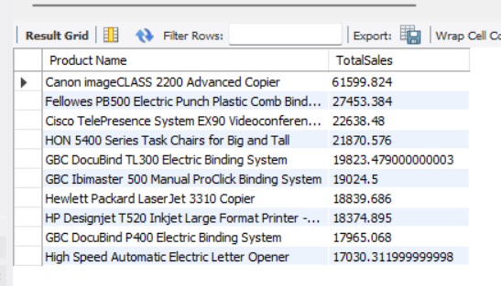
SELECT YEAR(STR_TO_DATE(`Order Date`,'%m/%d/%Y')) AS Year,MONTH(STR_TO_DATE(`Order Date`,'%m/%d/%Y')) AS Month,SUM(Sales) AS TotalSales FROM `sample - superstore` GROUP BY Year, Month ORDER BY Year, Month;
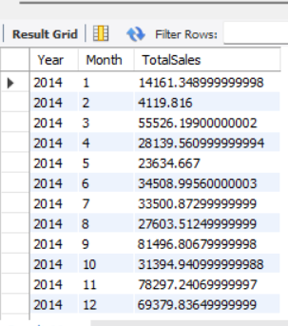

6.Solve use cases (monthly trends, top customers, duplicates).

SELECT `Customer Name`,SUM(Sales) AS TotalSales FROM `sample - superstore` GROUP BY `Customer Name` ORDER BY TotalSales DESC LIMIT 10;
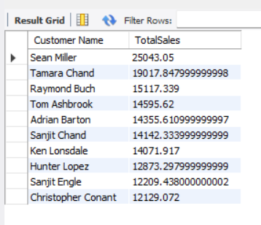

SELECT `Order ID`, COUNT(*) AS DuplicateCount FROM `sample - superstore` GROUP BY `Order ID` HAVING COUNT(*) > 1;
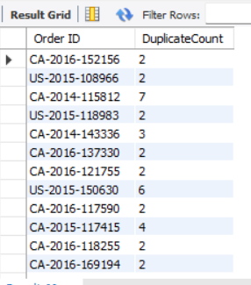
SELECT `Product Name`, SUM(Profit) AS TotalProfiT FROM `sample - superstore` GROUP BY `Product Name` ORDER BY TotalProfit DESC LIMIT 10;
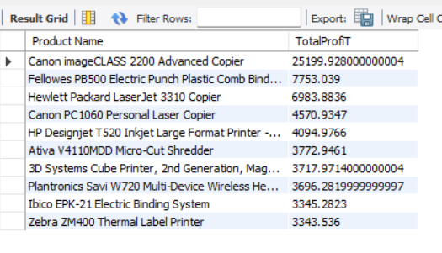
7.Validate results (row counts, data quality).
SELECT COUNT(*) AS Total_NumberOfRecords FROM `sample - superstore`;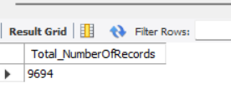
SELECT COUNT(*) AS NullSales FROM `sample - superstore` WHERE Sales IS NULL;
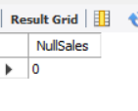

SELECT * FROM `sample - superstore` WHERE Profit < 0;
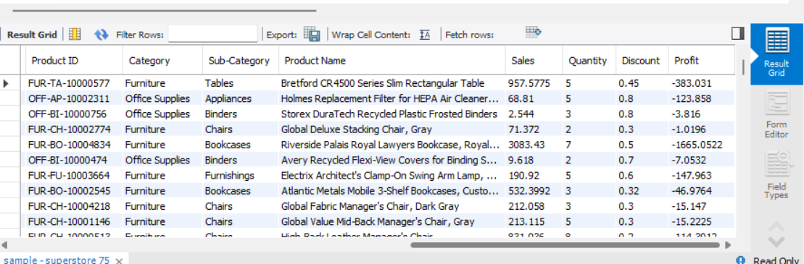

Summary:
For this assignment, I imported the Superstore dataset into MySQL Workbench by creating a database named assignment2 and loading the CSV file containing 9,694 records. I explored the dataset by examining the table structure, viewing sample records, and verifying the total number of records.
I applied various WHERE filters to analyse data based on regions, categories, sales ranges, order dates, and ship dates. This helped me understand how SQL can be used to retrieve specific subsets of data according to business requirements.
I performed aggregation analysis using GROUP BY to calculate total sales, total quantity sold, and average sales across different categories and regions. I also used ORDER BY and LIMIT clauses to identify the top-performing categories, customers, and products based on sales.
To address business use cases, I analysed monthly sales trends, identified the top customers contributing to revenue, detected duplicate order records, and evaluated the most profitable products. Finally, I validated the dataset by checking the total record count, identifying missing sales values, and analysing transactions with negative profit to assess data quality.
Through this assignment, I gained practical experience in SQL data analysis, including data exploration, filtering, aggregation, sorting, trend analysis, and data validation using MySQL Workbench.

